

ANADOLU UNIVERSITY

FACULTY OF ENGINEERING

DUYARLIOL

Hakan Yıldız

Okan Öztaban

A Bachelor of Science Project

Department of Computer Engineering

May 2017

DUYARLIOL

by

Hakan YILDIZ - 30928274948

Okan ÖZTABAN -29122110244

Submitted in partial fulfillment of the requirements for the degree of Bachelor of Science in Computer Engineering is approved by the following scientific committee members.

Date of Approval : March 27 , 2017

Member (Advisor) : Doç. Dr. Özgür YILMAZEL

Member : Yard. Doç. Dr. Ahmet ARSLAN

Member : Öğr. Gör. Emre KAÇMAZ

ABSTRACT

**Online shopping is more preferred in recent times due to the use of credit cards.   
Nevertheless, the rate of individual borrowing that people have is increasing. State and banks are encouraging instead of creating awareness and awareness on the individual, causing this increase**

**The main purpose of our project is to aim at a web sensitivity project which takes some basic information before completing the shopping to our clients who want to make online shopping and then makes a short test so that they can think about how much they need for the product they are buying and how they need it and leave the final decision to themselves.**

Keywords: Online Shopping, Credit Cards, Sensitivity, Web

ÖZET

Son yıllarda teknolojinin büyük bir hızla gelişmesinden dolayı, bireylerin bilgisayar, akıllı telefon ve birçok elektronik alet kullanımı artmıştır. Bununla beraber internetin yaygınlaşmasıyla e-ticaret sitelerinin sayılarına her geçen gün kat ve kat artmaktadır. Kullanıcıların istedikleri herhangi bir ürünü internet üzerinden kolay bir şekilde alabilmeleri ve ayrıca firmaların ürünlerini daha uygun fiyatlara satmaları e-ticaret sitelerinden alışverişi arttırmaktadır. Tüketim çağı dediğimiz bu çağda, kullanıcıların alışveriş sayıları artar iken bireysel borçlanmaları da büyük bir hızda artış göstermektedir. Devlet ve bankalar, bireyler üzerinde farkındalık ve duyarlılık oluşturmak yerine satın almaya, harcama yapmaya teşvik etmeleri bu artışa da sebep olmaktadır.

Projemizin asıl amacı online alışveris yapmak isteyen bireylerin alışverişlerini tamamlamadan önce bazı temel bilgilerini alıp ,kısa bir teste tabi tutarak, ellerindeki bütçe ile alacak olduğu ürüne ne kadar ihtiyacı olup olmadıgını düşünmesini sağlayan ve tabiki de son kararı kendisine bırakan bir web duyarlılık projesidir.

Anahtar Kelimeler: Online Alışveriş, Kredi Kartı, Duyarlılık, Web

CONTENTS

Page

**1. INTRODUCTION v**

**1.1. Project Title v**

**1.2. Group Members v**

**1.3. Project Motivation v**

**1.4. Project Definition v**

**1.5. Scope of Project v**

**1.6. Gantt Chart vi**

**2. PLATFORM AND TECHNOLOGIES TO BE USED vii**

**2.1. ASP.NET vii**

**2.2. CSS vii**

**2.3. HTML viii**

**2.4. JAVASCPRİPT viii**

**2.5. MSSQL viii**

**2.6. POLYMER ix**

**2.7. CHROME EXTENSION ix**

**3. CONCLUSIONS x**

**4. REFERENCES xi**

1. INTRODUCTION

1.1. Project Title

DUYARLIOL

1.2. Group Members

Hakan Yıldız

Okan Öztaban

1.3. Project Motivation

The user will be redirected to our website before the user completes the

exchange. Our system will want some information of its own from the user. After the information, the system, based on the information entered, The user will be thought for the second time about the product he will need or not need .

1.4. Project Definition

Online shopping has increased with the increase in the use of credit cards in recent years. This has led to an increase in the individual debts of individuals. Our system is a susceptibility project intended to make people think twice about shopping.

1.5. Scope of Project

Anyone who makes an online purchase can go to our test and evaluate the price for that shopping.

1.6. Gantt Chart

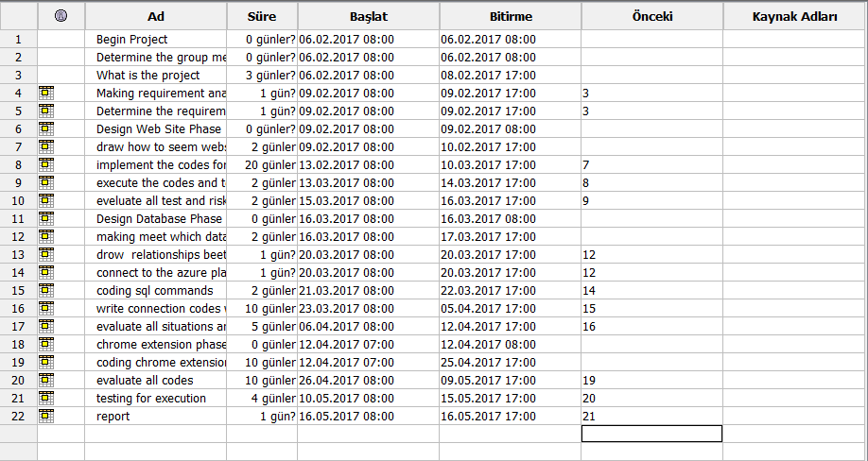

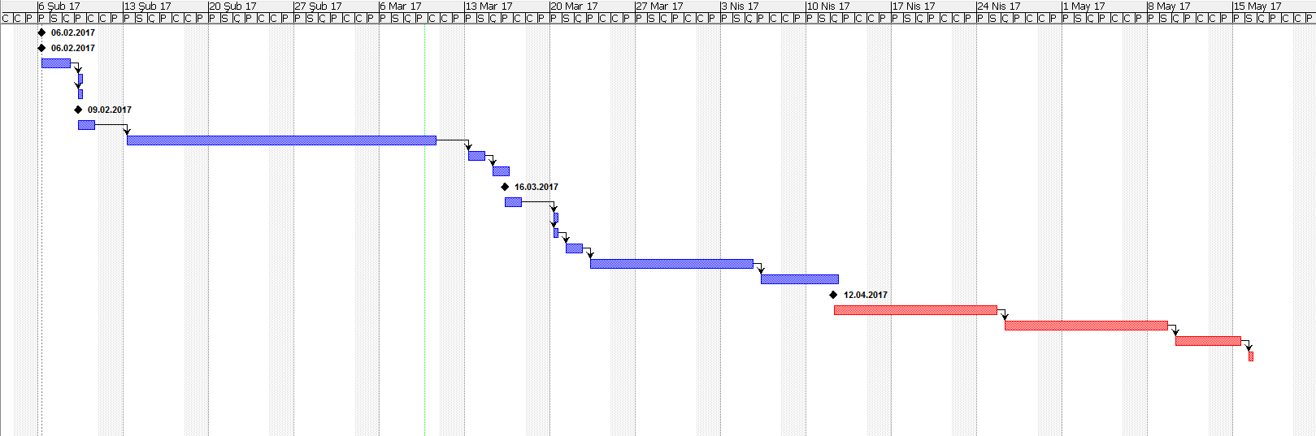

2. Platform and technologies to be used

2.1. ASP.NET

ASP.NET is an open-source server-side web application framework designed for web development to produce dynamic web pages. It was developed by Microsoft to allow programmers to build dynamic web sites, web applications and web services.

It was first released in January 2002 with version 1.0 of the .NET Framework, and is the successor to Microsoft's Active Server Pages (ASP) technology. ASP.NET is built on the Common Language Runtime (CLR), allowing programmers to write ASP.NET code using any supported .NET language. The ASP.NET SOAP extension framework allows ASP.NET components to process SOAP messages.

ASP.NET is in the process of being re-implemented as a modern and modular web framework, together with other frameworks like Entity Framework. The new framework will make use of the new open-source .NET Compiler Platform (code-name "Roslyn") and be cross platform. ASP.NET MVC, ASP.NET Web API, and ASP.NET Web Pages (a platform using only Razor pages) will merge into a unified MVC 6. The project is called ASP.NET Core.

.

2.2. CSS

Cascading Style Sheets (CSS) is a  style sheet language  used for describing the presentation   of a document written in a markup language. Although most often used to set the visual style of  web pages and user interfaces written in HTMl and XHTML, the language can be applied to any XML document, including plain XML , SVG and XUL, and is applicable to rendering in speech, or on other media. Along with HTML and JavaScript, CSS is a cornerstone technology used by most websites to create visually engaging webpages, user interfaces for web applications, and user interfaces for many mobile applications.

2.3. HTML

HyperText Markup Language (HTML) is the standard markup language for creating web pages and web applications. With Cascading Style Sheets (CSS) and JavaScript  it forms a triad of cornerstone technologies for the World Wide Web.  Web browsers receive HTML documents from a webserver or from local storage and render them into multimedia web pages. HTML describes the structure of a web page semantically and originally included cues for the appearance of the document.

.

2.4. JAVASCPRİPT

JavaScript is a high-level , dynamic, untyped and interpreted programming language .It has been standardized in the ECMAScript  language specification.Alongside HTML and CSS, JavaScript is one of the three core technologies of World Wide Web content production; the majority of websites employ it, and all modern Web browsers support it without the need for plug-ins.JavaScript is prototype-baseed with first class functions, making it a multi-paradign language, supporting,object-oriented ,imperative , and functional programming styles. It has an API for working with text,arrays , dates and reguşar expressions, but does not include anyI/O, such as networking, storage, or graphics facilities, relying for these upon the host environment in which it is embedded.

2.5. MSSQL

Microsoft SQL Server is a relational database management system developed by Microsoft. As a database server, it is a software product with the primary function of storing and retrieving data as requested by other software applications—which may run either on the same computer or on another computer across a network (including the Internet).

2.6. POLYMER

Polymer is an open-source Javascript library for building web applications using web components. The library is being developed by Google developers and contributors on Github. Modern desinn principles are implemented as a separate project using Google’s Material Design design principles.

Polymer provides a number of features over vanilla web components:

* Simplified way of creating custom elements
* Both One-way and Two-way data binding
* Computed properties
* Conditioanl and repeat templates
* Gesture events
* Library of Elements

2.7. CHROME EXTENSION

Google Chrome Extensions are browser extensions that modify the Google Chrome browser. These extensions are written using web technologies like HTML, JavaScript, and CSS.Google Chrome Extensions are downloadable through the Chrome Web Store(formerly the Google Chrome Extensions Gallery). By February 2010, over 2,200 extensions had been published by developers. All users with a Google Account are able to add extensions after developing them.

3. CONCLUSIONS

**At the end of our project, we intend to think twice about this person and to create this awareness for everybody.**

4. REFERENCES

1. <https://nicolargo.github.io/glances/>
2. <http://linuxcommand.org/man_pages/vmstat8.html>
3. [https://www.vim.org](https://www.vim.org/)
4. <https://www.jetbrains.com/clion/>
5. <https://lemp.io/>
6. [http://www.lkd.org.tr](http://www.lkd.org.tr/)
7. <http://man7.org/linux/man-pages/man2/socket.2.html>